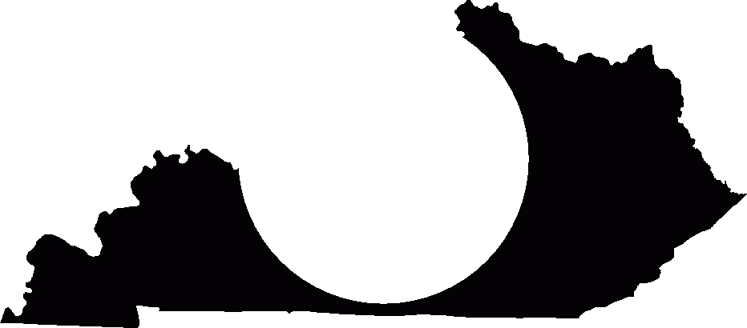

ROAD NAME:Xxxxxxx RoadREVIEW STATUS

ROUTE NO.:KY XXXXDISTRICT:X

STATION TO STATION:10+92 – 13+31CO DRAINAGE:

DESIGNED BY:XXXXXXX, Inc.BRIDGES:

BRIDGE
INLET SPACING

BOX CULVERT
STORM SEWER

ARCH CULVERT
CHANNEL CHANGE

PIPE CULVERT
DRY STRUCTURE

OTHER
CHANNEL CHANGE

KENTUCKY TRANSPORTATION CABINET
DIVISION OF HIGHWAY DESIGN

V05-08
DRAINAGE DESIGN DOCUMENTATION

STATE PROJECT NO.:FDXX XXX XXXX 001-002
FDXX XXX XXXX 002-003
ADVANCE
FEDERAL PROJECT NO.:XXXXXXXXXX

COUNTY:Fayette - ClarkITEM NO.:X-XXXX.XEMARS NO.:XXXXXXXD

